**AangularJS Authentication using Auth0**

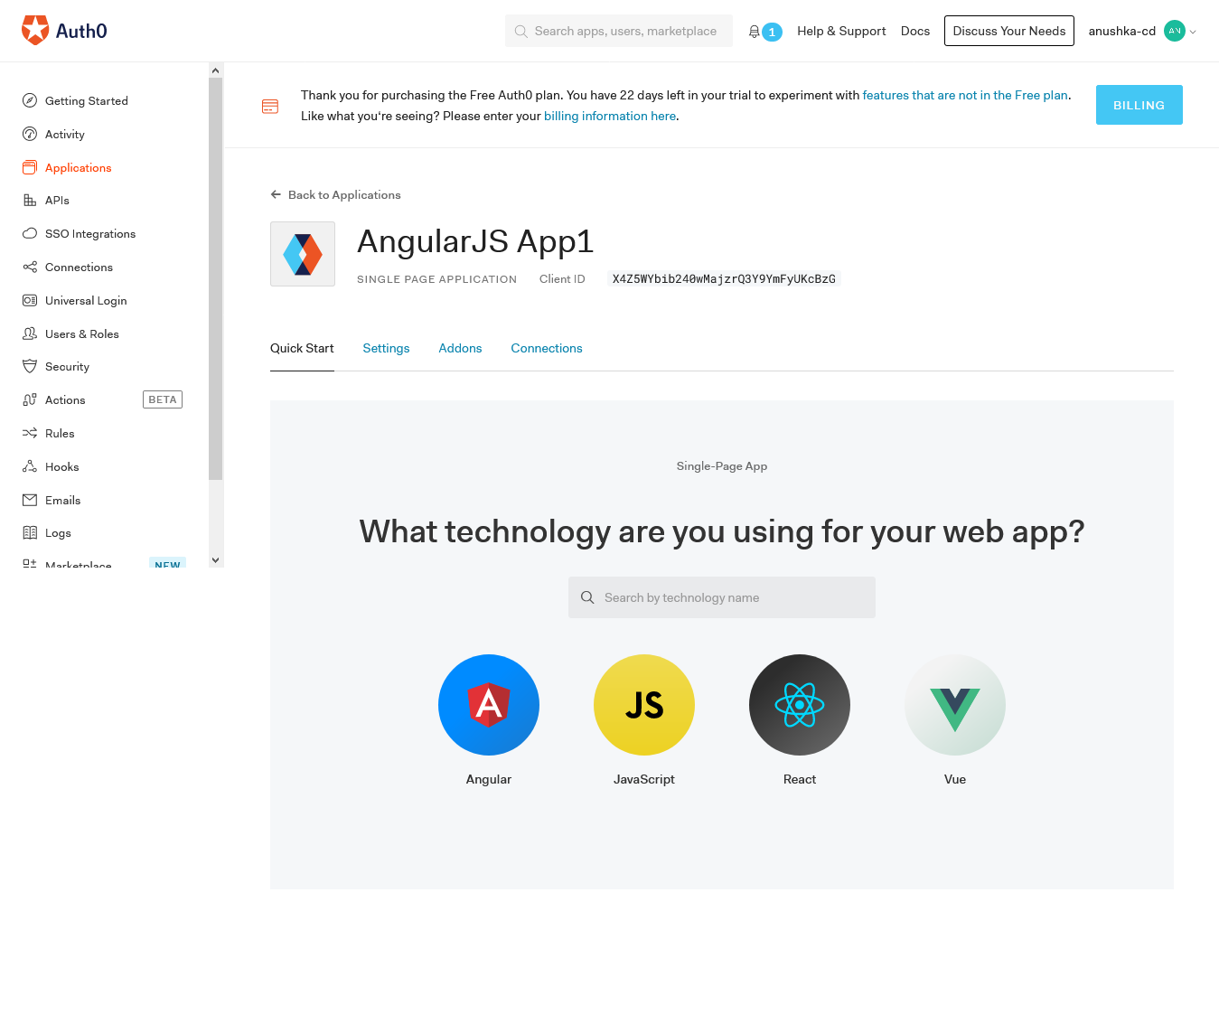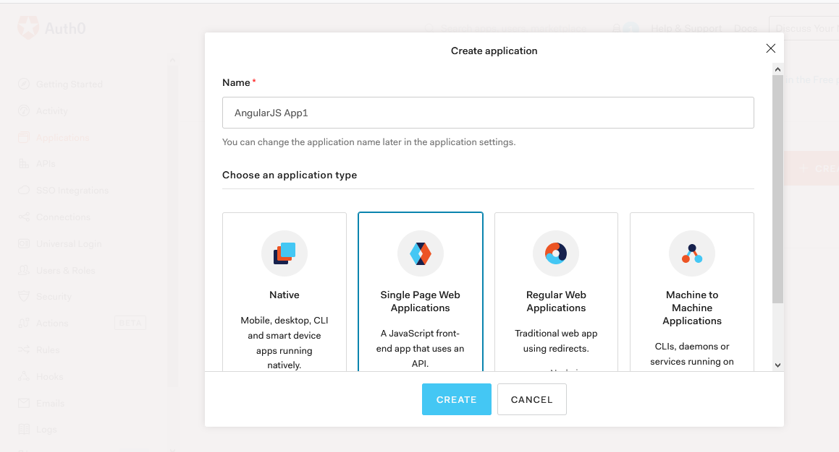

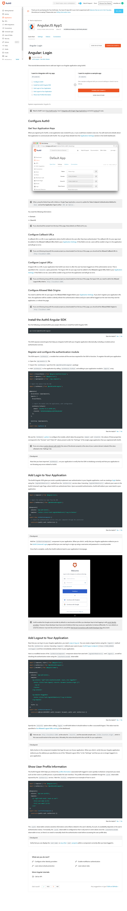

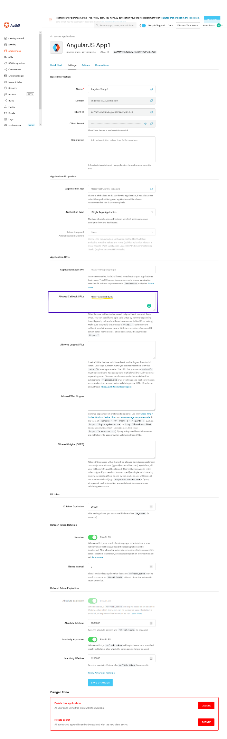

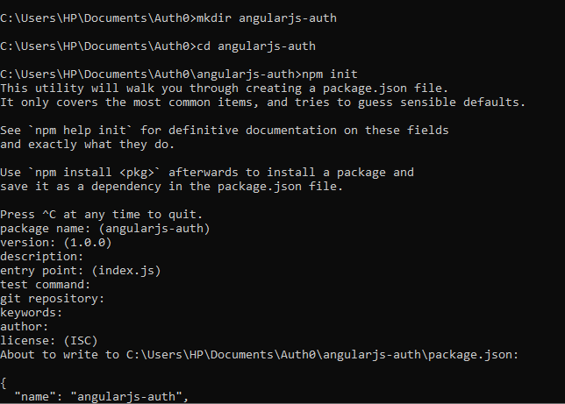

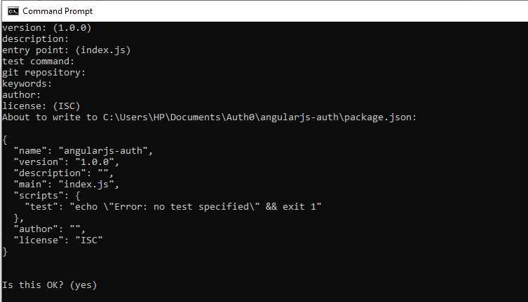

C:\Users\HP\Documents\Auth0\angularjs-auth>npm i --save angular @uirouter/angularjs auth0-js angular-auth0 bootstrap

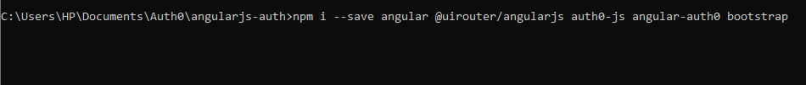



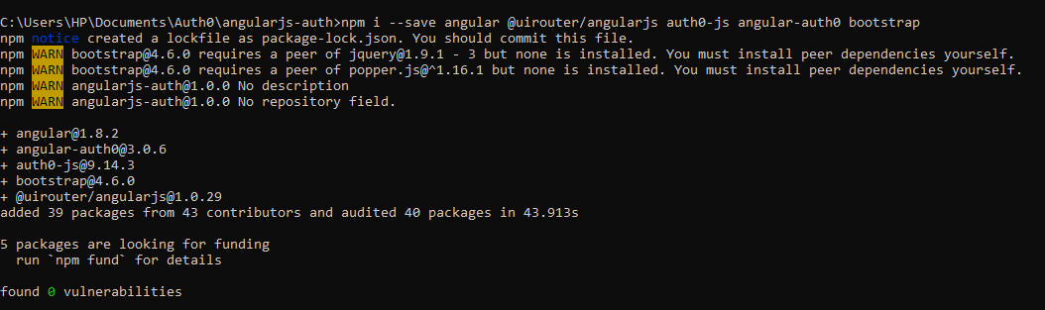

npm i -g http-server

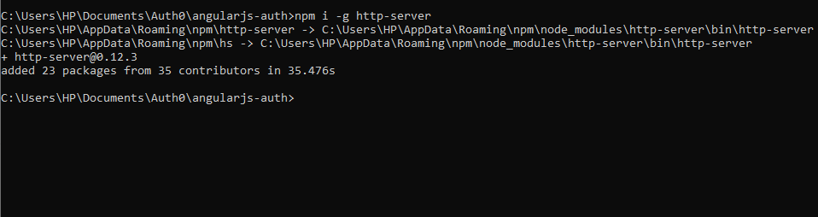

http-server -p 3000

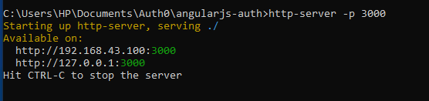

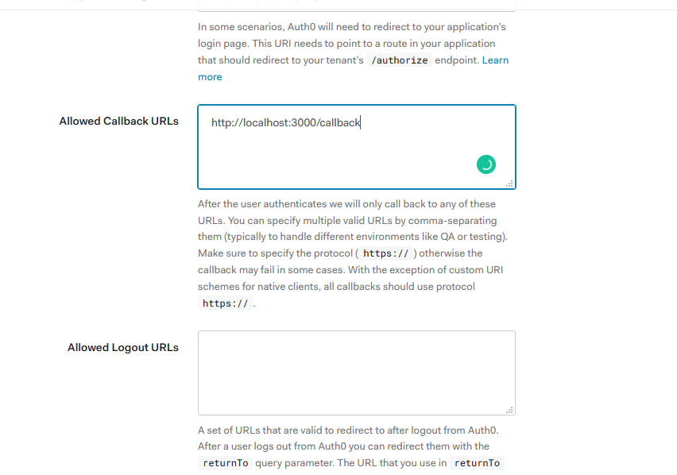

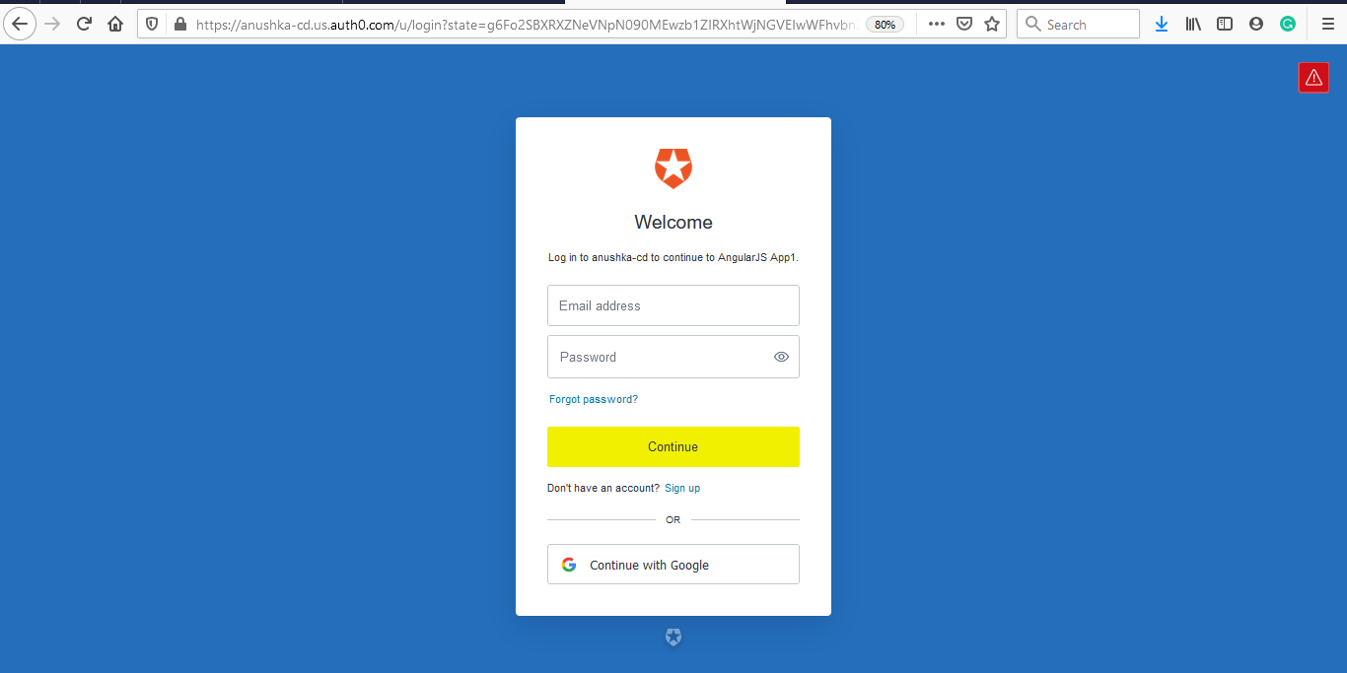

**LOG IN**

app.js

(function(){

angular

.module('app',['auth0.auth0','ui.router'])

.config(config);

config.$inject=[

    '$stateProvider',

    '$locationProvider',

    '$urlRouterProvider',

    'angularAuth0Provider'

];

function config($stateProvider,$locationProvider,$urlRouterProvider,angularAuth0Provider)

{

   $stateProvider.state('home',{

    url:'/',

    controller:'HomeController',

    templateUrl:'app/home/home.html',

    controllerAs:'vm'

   })

   .state('callback',{

      url:'/callback',

      controller:'CallbackController',

      templateUrl:'app/callback/callback.html',

      controllerAs :'vm'

   }) ;

   angularAuth0Provider.init({

      clientID:'X4Z5WYbib240wMajzrQ3Y9YmFyUKcBzG',

      domain:'anushka-cd.us.auth0.com',

      responseType:'token id_token',

      redirectUri:'http://localhost:3000/callback',

      scope:'openid'

   });

$urlRouterProvider.otherwise('/');

$locationProvider.hashPrefix('');

$locationProvider.html5Mode(true);

}

})();

Auth.service.js

(function(){

    angular.module('app').service('authService',authService);

    authService.$inject=['$state','angularAuth0','$timeout'];

    function authService($state,angularAuth0,$timeout){

        function login(){

            angularAuth0.authorize();

        }

        return{

            login:login

        }

    }

})();

Add this in index.html

<script src="app/auth/auth.service.js"></script>

navbar.directive.js

(function(){

angular.module('app').directive('navbar',navbar);

function navbar(){

    return{

        templateUrl:'app/navbar/navbar.html',

        controller: navbarController,

        controllerAs:'vm'

    }

}

navbarController.$inject=['authService'];

function navbarController(authService){

    var vm=this;

    vm.auth=authService;

}

})();

navbar.html

<nav class="navbar navbar-default">

<div class="container-fluid">

    <div class="navbar-header">

<a href="#" class="navbar-brand">AngularJS Auth</a>

    </div>

    <div class="collapse navbar-collapse">

        <ul class="nav navbar-nav">

          <li>

              <a href="">Home</a>

        </li>

          <li>

              <a ng-click="vm.auth.login()">Log In</a>

            </li>

          <li>

              <a href="">Log Out</a>

            </li>

        </ul>

   </div>

</div>

</nav>

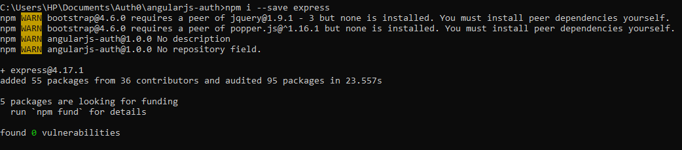

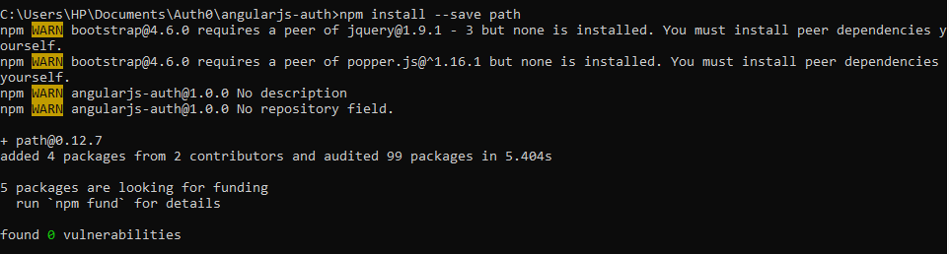

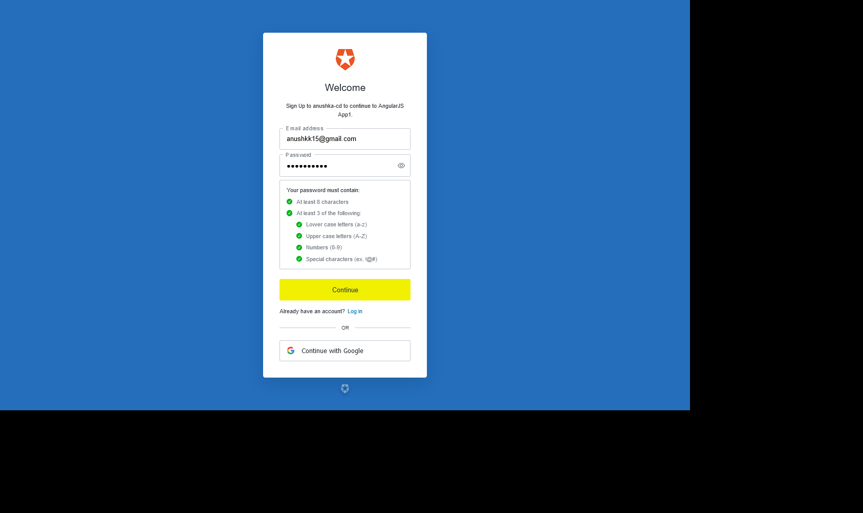

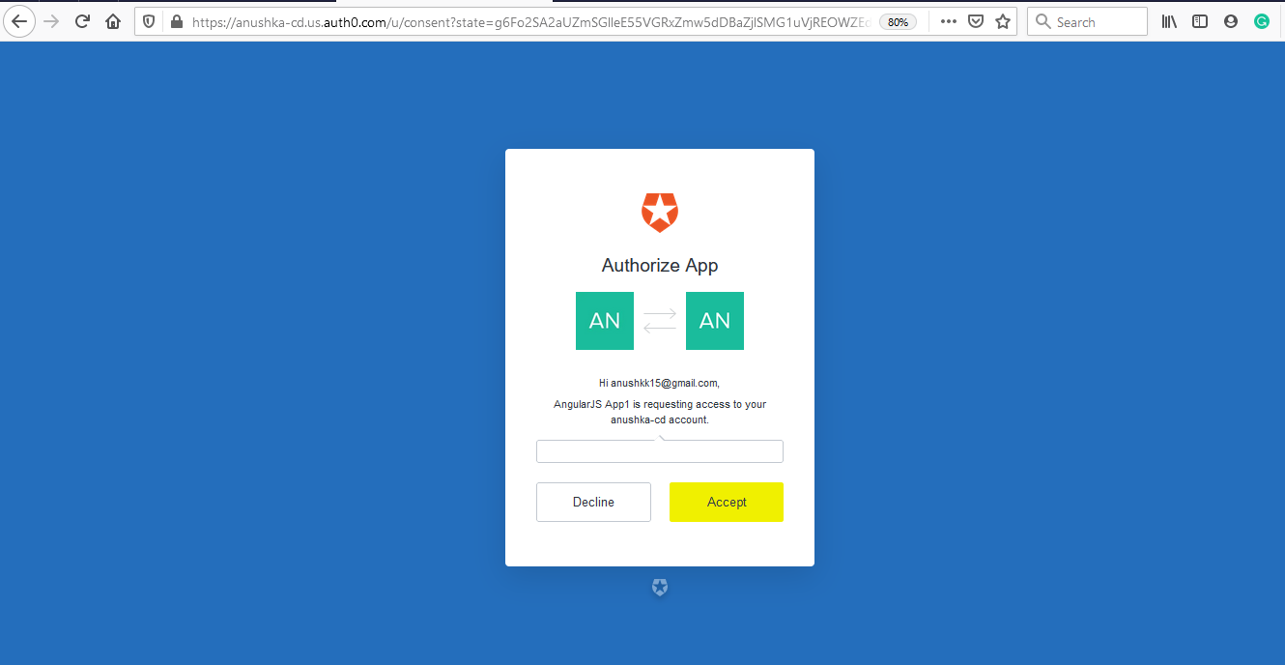

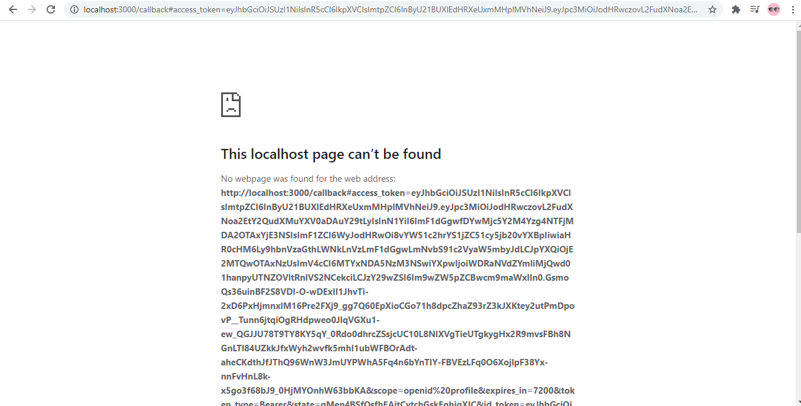

Or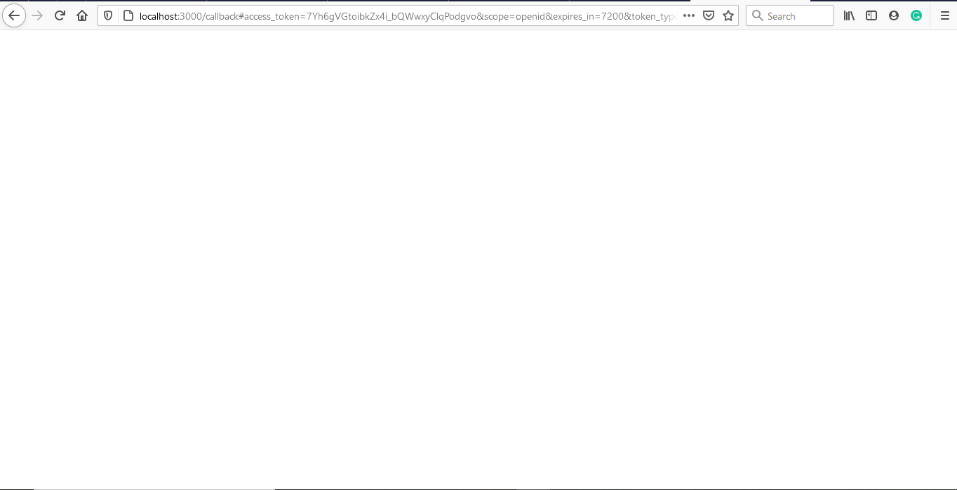

Server.js

const express= require('express');

const app = express();

const path=require('path');

app.use('/',express.static(__dirname +'/'));

app.get('/*',function (req,res){

    res.sendFile(path.join(__dirname + '/index.html'));

});

/*var server = app.listen(3000, function () {

var host = server.address().address

var port = server.address().port

console.log("Example app listening at http://%s:%s", host, port)

})*/

const hostname='localhost';

const port=3000;

const server =app.listen(port,hostname,()=>{

    console.log(`Server listening at http://${hostname}:${port}`);

});

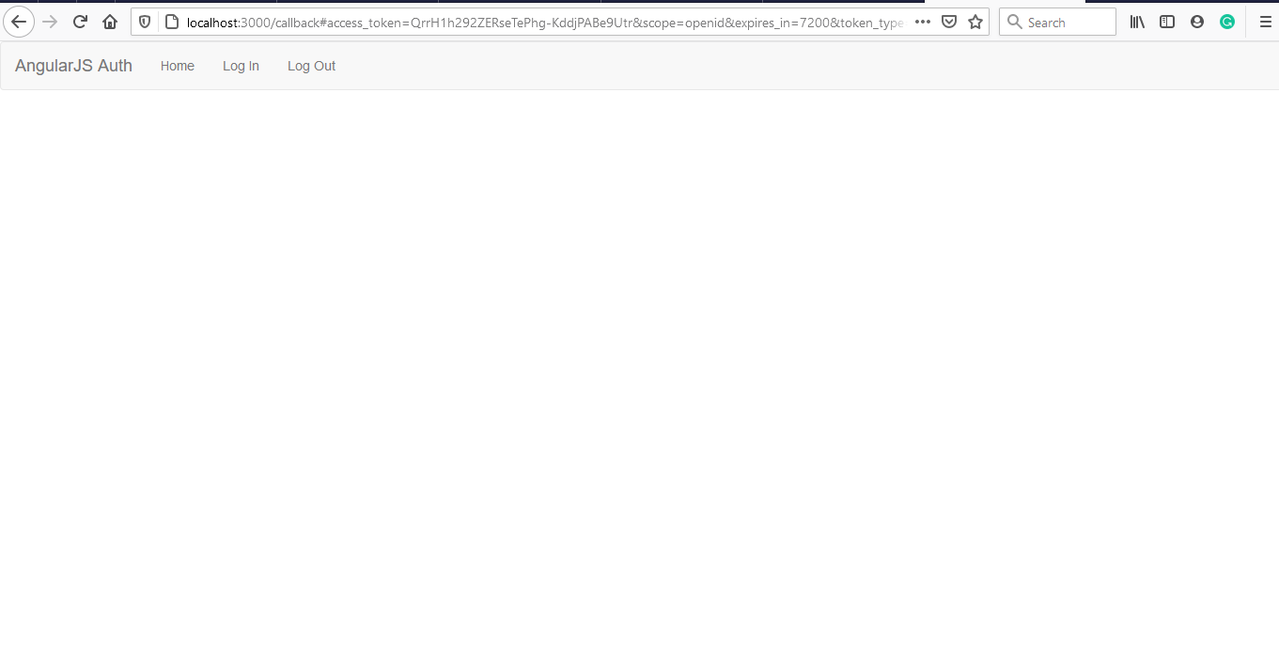

Result of auth0

Auth.service.js

(function(){

    angular.module('app').service('authService',authService);

    authService.$inject=['$state','angularAuth0','$timeout'];

    function authService($state,angularAuth0,$timeout){

        function login(){

            angularAuth0.authorize();

        }

        function handleAuthentication(){

            angularAuth0.parseHash(function(err,authResult){

               if(authResult && authResult.accessToken && authResult.idToken)

               {

               //setSession(authResult)

                console.log(authResult);

               }

             });

        }

        return{

            login:login,

            handleAuthentication:handleAuthentication

        };

    }

})();

app.run.js

(function(){

    angular.module('app').run(run);

    run.$inject=['authService'];

    function run(authService){

        authService.handleAuthentication()

    }

})();

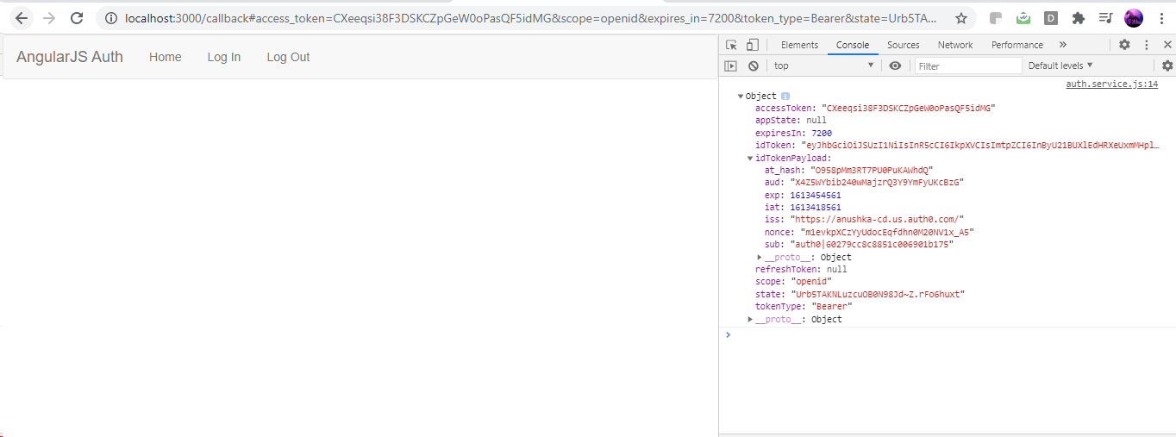

(function(){

    angular.module('app').service('authService',authService);

    authService.$inject=['$state','angularAuth0','$timeout'];

    function authService($state,angularAuth0,$timeout){

        function login(){

            angularAuth0.authorize();

        }

        function handleAuthentication(){

            angularAuth0.parseHash(function(err,authResult){

               if(authResult && authResult.accessToken && authResult.idToken)

               {

               setSession(authResult)

                //console.log(authResult);

               }

             });

        }

        function setSession(authResult){

            var expiresAt=JSON.stringify(

                (authResult.expiresIn * 1000)+ new Date().getTime()

            );

            localStorage.setItem('access_token',authResult.accessToken);

            localStorage.setItem('id_token',authResult.idToken);

            localStorage.setItem('expires_at',expiresAt);

        }

        return{

            login:login,

            handleAuthentication:handleAuthentication

        };

    }

})();

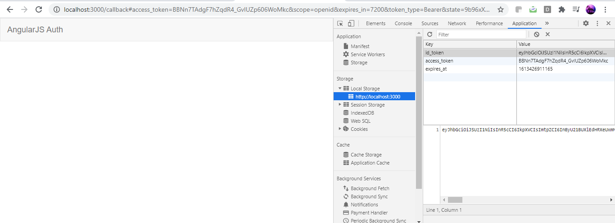

**LOG OUT**

(function(){

    angular.module('app').service('authService',authService);

    authService.$inject=['$state','angularAuth0','$timeout'];

    function authService($state,angularAuth0,$timeout){

        function login(){

            angularAuth0.authorize();

        }

        function handleAuthentication(){

            angularAuth0.parseHash(function(err,authResult){

               if(authResult && authResult.accessToken && authResult.idToken)

               {

               setSession(authResult)

                //console.log(authResult);

               }

             });

        }

        function setSession(authResult){

            var expiresAt=JSON.stringify(

                (authResult.expiresIn * 1000)+ new Date().getTime()

            );

            localStorage.setItem('access_token',authResult.accessToken);

            localStorage.setItem('id_token',authResult.idToken);

            localStorage.setItem('expires_at',expiresAt);

        }

        function logout(){

            localStorage.removeItem('access_token');

            localStorage.removeItem('id_token');

            localStorage.removeItem('expires_at');

        }

        return{

            login:login,

            handleAuthentication:handleAuthentication,

            logout:logout

        };

    }

})();

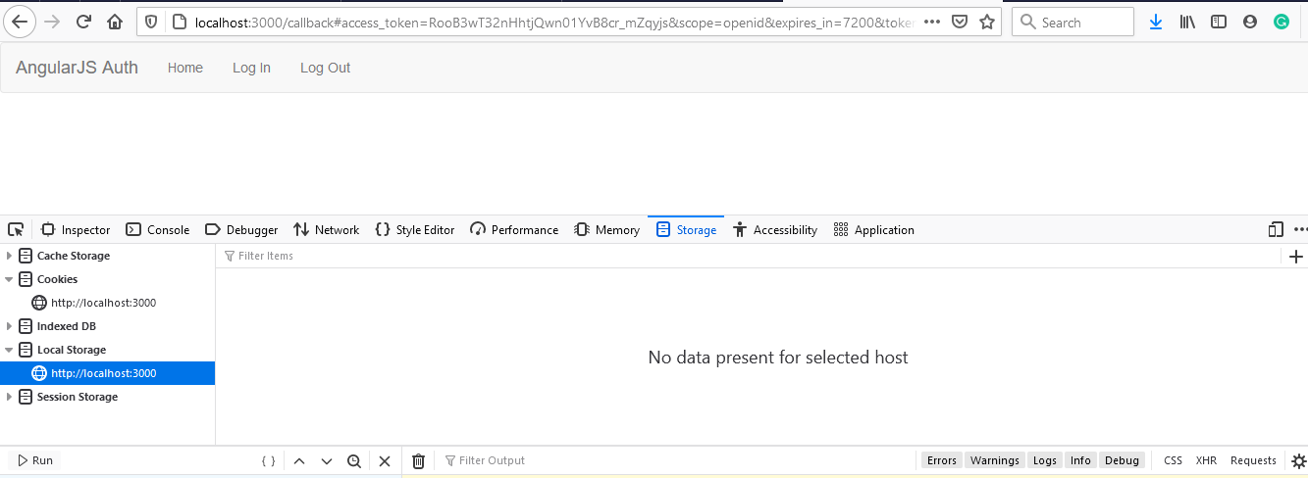

**Whether they are authenticated or not?**

(function(){

    angular.module('app').service('authService',authService);

    authService.$inject=['$state','angularAuth0','$timeout'];

    function authService($state,angularAuth0,$timeout){

        function login(){

            angularAuth0.authorize();

        }

        function handleAuthentication(){

            angularAuth0.parseHash(function(err,authResult){

               if(authResult && authResult.accessToken && authResult.idToken)

               {

               setSession(authResult)

                //console.log(authResult);

               }

             });

        }

        function setSession(authResult){

            var expiresAt=JSON.stringify(

                (authResult.expiresIn * 1000)+ new Date().getTime()

            );

            localStorage.setItem('access_token',authResult.accessToken);

            localStorage.setItem('id_token',authResult.idToken);

            localStorage.setItem('expires_at',expiresAt);

        }

        function logout(){

            localStorage.removeItem('access_token');

            localStorage.removeItem('id_token');

            localStorage.removeItem('expires_at');

        }

        function isAuthenticated(){

            var expiresAt=JSON.parse(localStorage.getItem('expires_at'));

            return new Date().getTime() < expiresAt ;

        }

        return{

            login:login,

            handleAuthentication:handleAuthentication,

            logout:logout,

            isAuthenticated:isAuthenticated

        };

    }

})();

**Navbar.html**

<nav class="navbar navbar-default">

<div class="container-fluid">

    <div class="navbar-header">

<a href="#" class="navbar-brand">AngularJS Auth</a>

    </div>

    <div class="collapse navbar-collapse">

        <ul class="nav navbar-nav">

          <li>

              <a href="">Home</a>

        </li>

          <li ng-if=!vm.auth.isAuthenticated()>

              <a ng-click="vm.auth.login()">Log In</a>

            </li>

          <li ng-if=vm.auth.isAuthenticated()>

              <a ng-click="vm.auth.logout()">Log Out</a>

            </li>

        </ul>

   </div>

</div>

</nav>

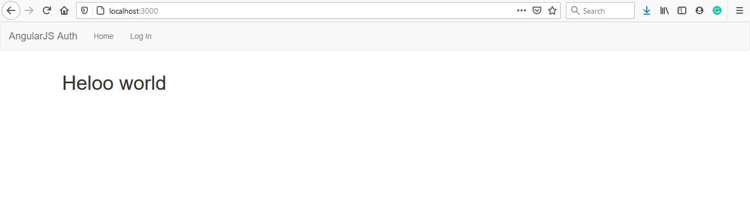

**After clicking login**

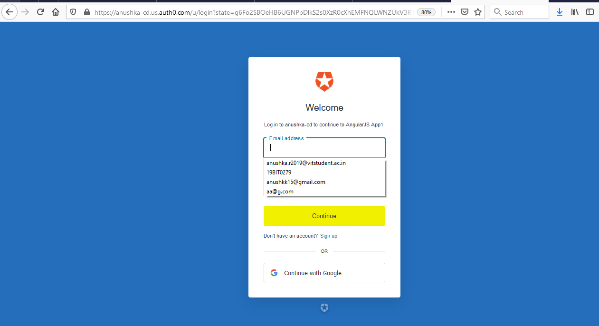

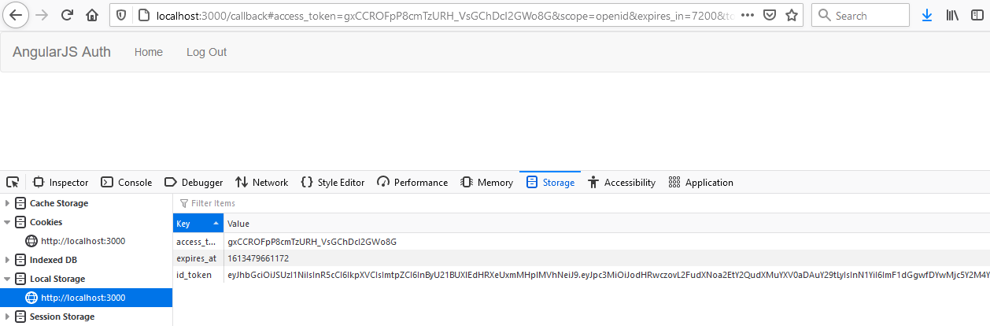

**After you click logout**

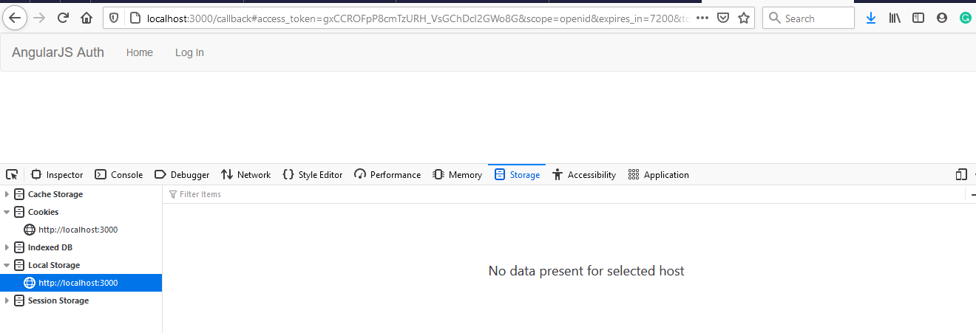

**Profile:**

**Profile.controller.js**

(function(){

    angular.module('app').controller('ProfileController',profileController)

function profileController(){}

})();

**Auth.service.js**

function handleAuthentication(){

            angularAuth0.parseHash(function(err,authResult){

               if(authResult && authResult.accessToken && authResult.idToken)

               {

               setSession(authResult)

                console.log(authResult);

               }

             });

        }

**App.js**

 angularAuth0Provider.init({

      clientID:'X4Z5WYbib240wMajzrQ3Y9YmFyUKcBzG',

      domain:'anushka-cd.us.auth0.com',

      responseType:'token id_token',

      redirectUri:'http://localhost:3000/callback',

      scope:'openid profile'

   });

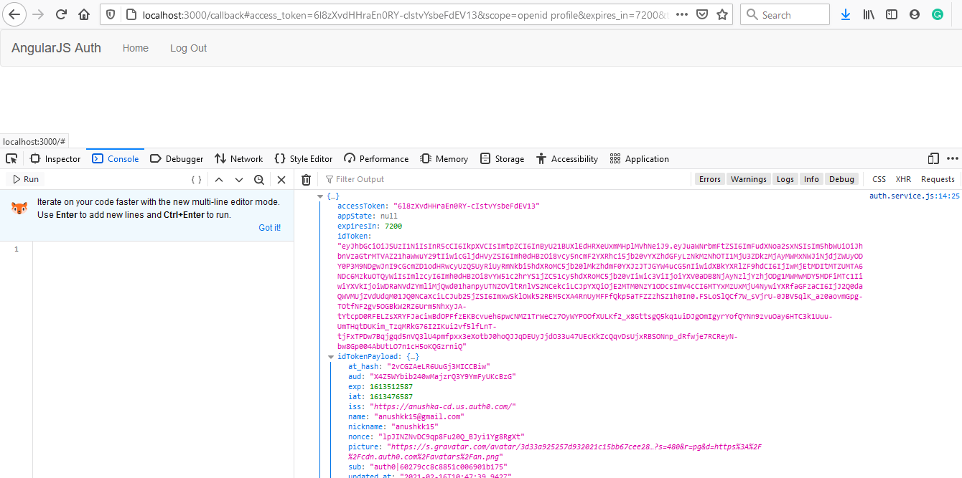

**Profile.controller.js**

(function(){

    angular.module('app').controller('ProfileController',profileController)

function profileController(){

    var vm=this;

    vm.profile=JSON.parse(localStorage.getItem('profile'));

}

})();

**Profile.html**

<div class="panel panel-default">

<div class="panel-heading">

    <h3>

        Profile

    </h3>

</div>

<div class="panel-body">

    <img ng-src="{{vm.profile.picture}}" alt="avatar">

<div>

<label for="nickname">Nickname</label>

<h3>{{vm.profile.nickname}}</h3>

<label for="name">Name</label>

<h3>{{vm.profile.name}}</h3>

</div>

</div>

</div>

**Auth.service.js**

(function(){

    angular.module('app').service('authService',authService);

    authService.$inject=['$state','angularAuth0','$timeout'];

    function authService($state,angularAuth0,$timeout){

        function login(){

            angularAuth0.authorize();

        }

        function handleAuthentication(){

            angularAuth0.parseHash(function(err,authResult){

               if(authResult && authResult.accessToken && authResult.idToken)

               {

               setSession(authResult)

                //console.log(authResult);

               }

             });

        }

        function setSession(authResult){

            var expiresAt=JSON.stringify(

                (authResult.expiresIn * 1000)+ new Date().getTime()

            );

            var profile={

                name:authResult.idTokenPayload.name,

                nickname:authResult.idTokenPayload.nickname,

                picture:authResult.idTokenPayload.picture

            }

            localStorage.setItem('access_token',authResult.accessToken);

            localStorage.setItem('id_token',authResult.idToken);

            localStorage.setItem('expires_at',expiresAt);

            localStorage.setItem('profile',JSON.stringify(profile));

        }

        function logout(){

            localStorage.removeItem('access_token');

            localStorage.removeItem('id_token');

            localStorage.removeItem('expires_at');

            //localStorage.removeItem('profile');

        }

        function isAuthenticated(){

            var expiresAt=JSON.parse(localStorage.getItem('expires_at'));

            return new Date().getTime() < expiresAt ;

        }

        return{

            login:login,

            handleAuthentication:handleAuthentication,

            logout:logout,

            isAuthenticated:isAuthenticated

        };

    }

})();

**App.js**

(function(){

angular

.module('app',['auth0.auth0','ui.router'])

.config(config);

config.$inject=[

    '$stateProvider',

    '$locationProvider',

    '$urlRouterProvider',

    'angularAuth0Provider'

];

function config($stateProvider,$locationProvider,$urlRouterProvider,angularAuth0Provider)

{

   $stateProvider

   .state('home',{

    url:'/',

    controller:'HomeController',

    templateUrl:'app/home/home.html',

    controllerAs:'vm'

   })

   .state('callback',{

      url:'/callback',

      controller:'CallbackController',

      templateUrl:'app/callback/callback.html',

      controllerAs :'vm'

   })

   .state('profile',{

      url:'/profile',

      controller:'ProfileController',

      templateUrl:'app/profile/profile.html',

      controllerAs :'vm'

   }) ;

   angularAuth0Provider.init({

      clientID:'X4Z5WYbib240wMajzrQ3Y9YmFyUKcBzG',

      domain:'anushka-cd.us.auth0.com',

      responseType:'token id_token',

      redirectUri:'http://localhost:3000/callback',

      scope:'openid profile'

   });

$urlRouterProvider.otherwise('/');

$locationProvider.hashPrefix('');

$locationProvider.html5Mode(true);

}

})();

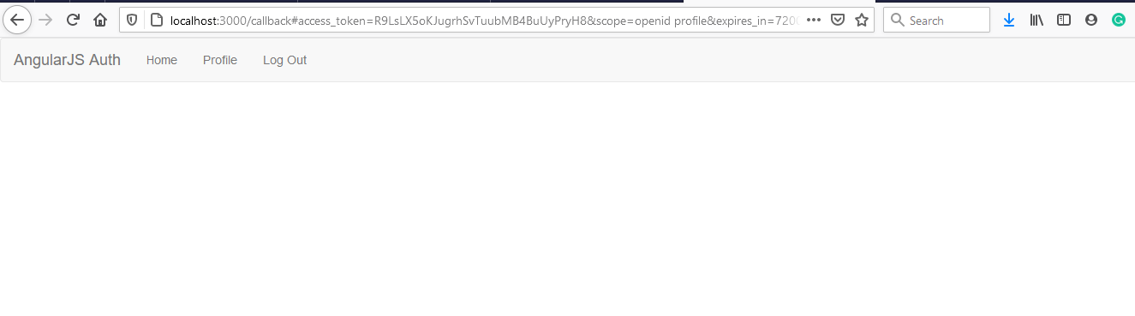

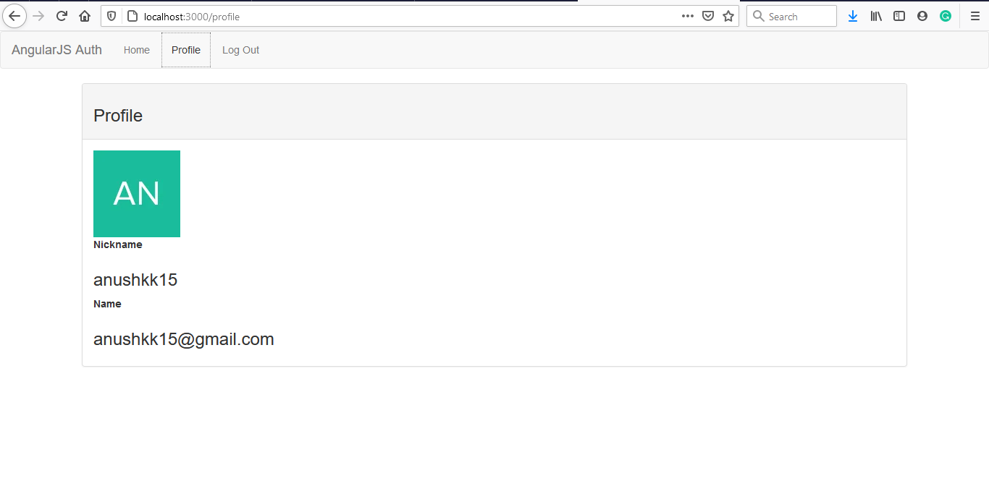

**Setting up server API with a protected resource**

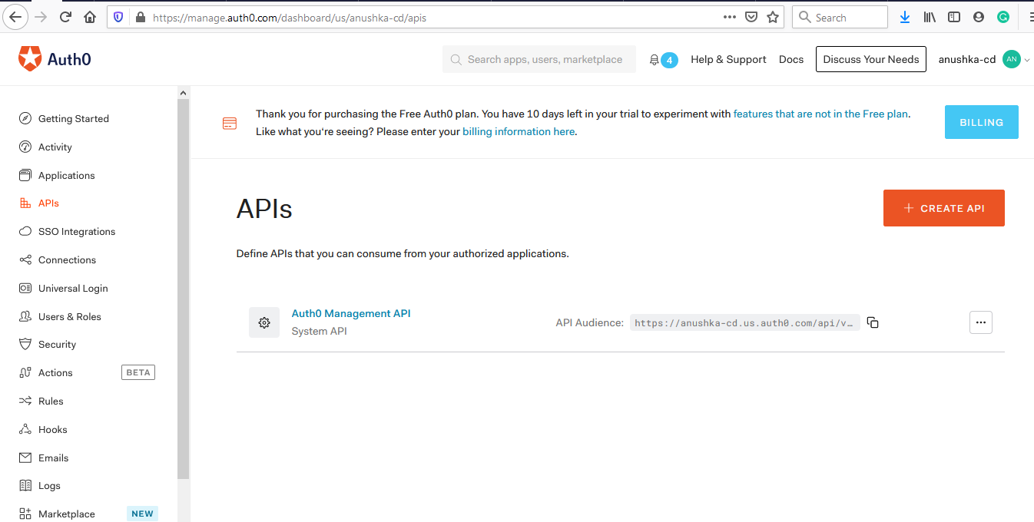

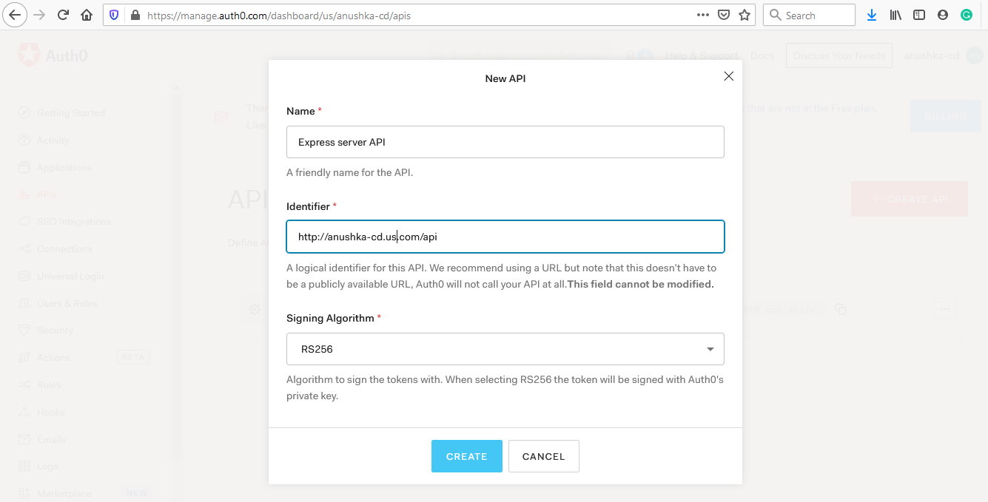

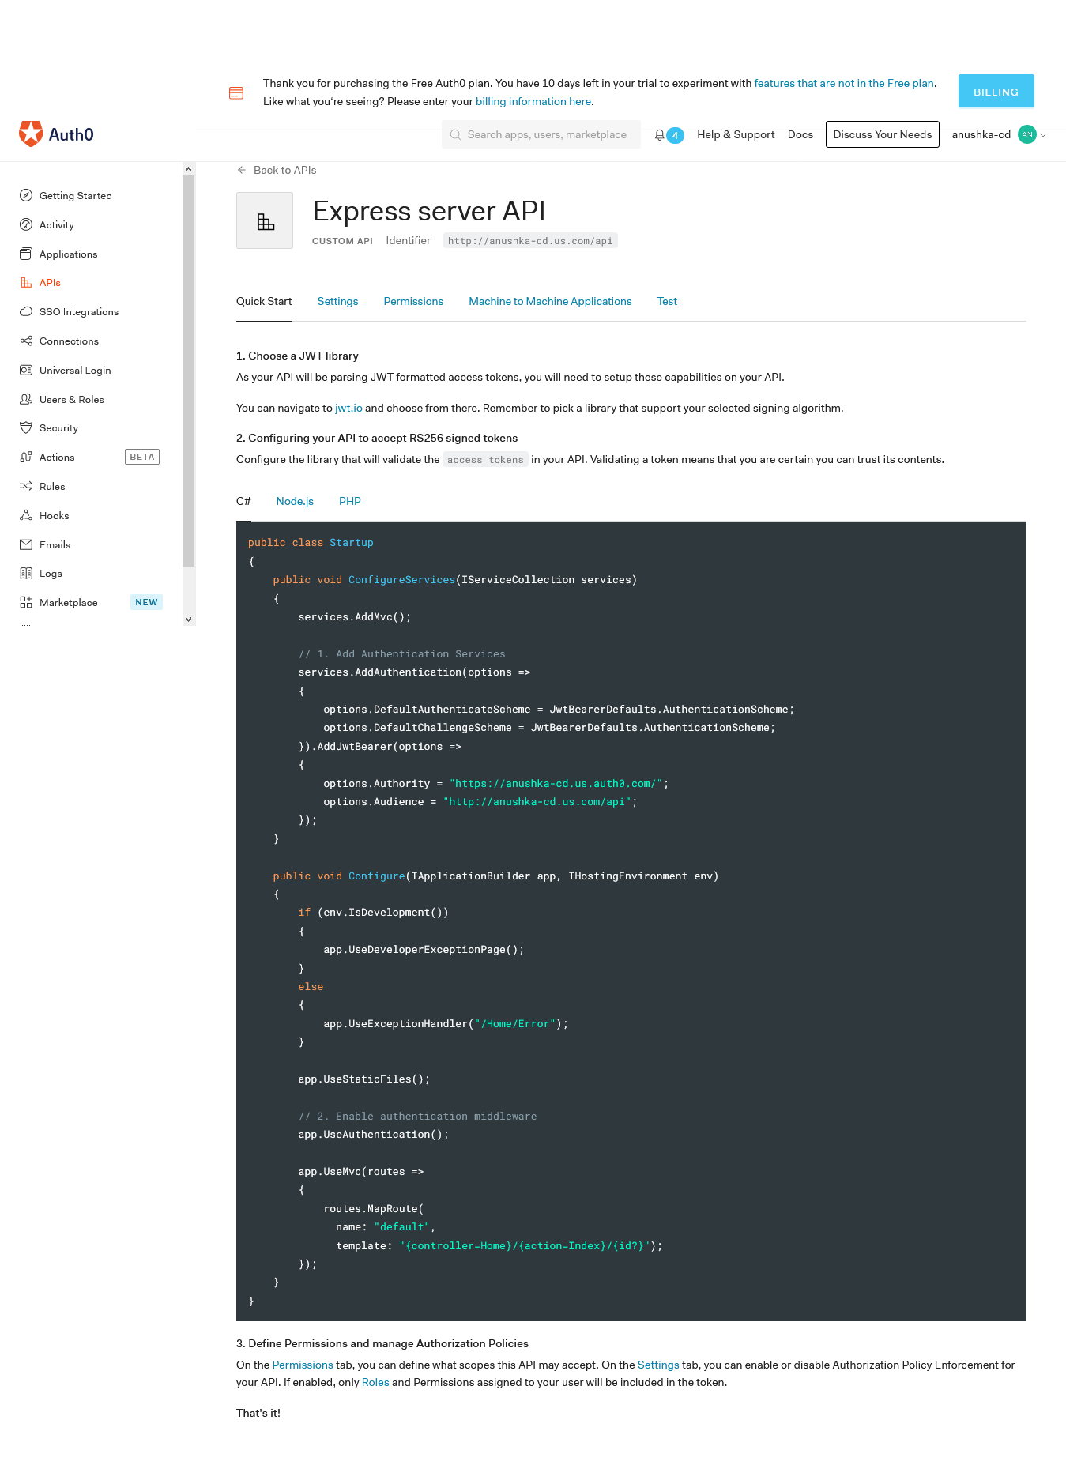

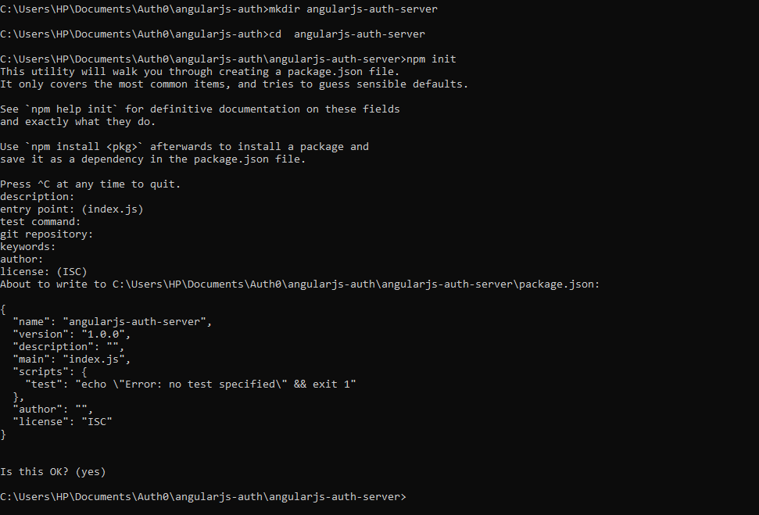

**npm i express express-jwt jwks-rsa cors –save**

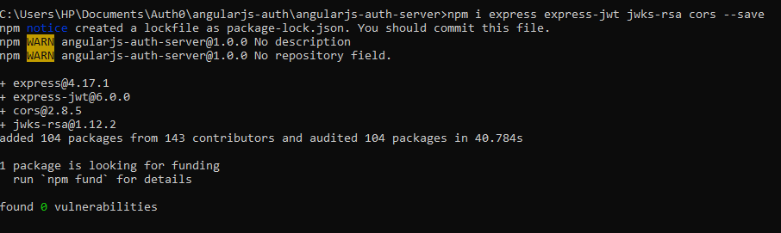

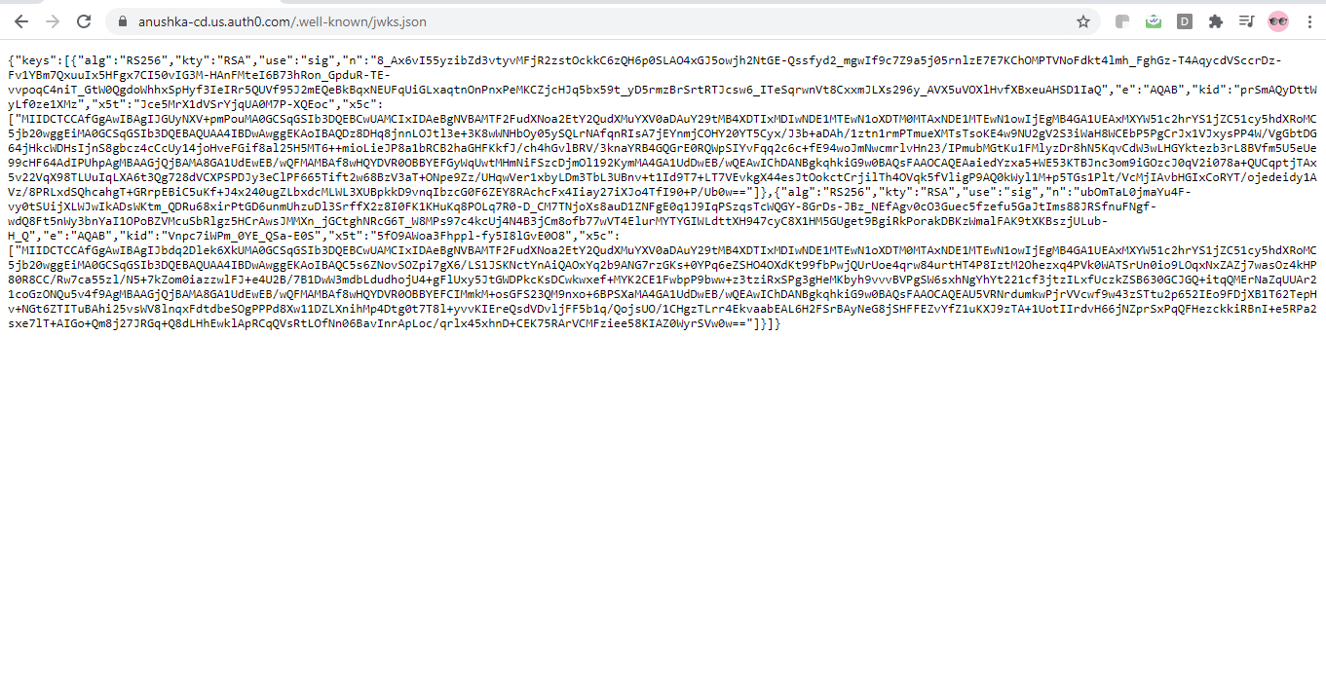

**In postman :**



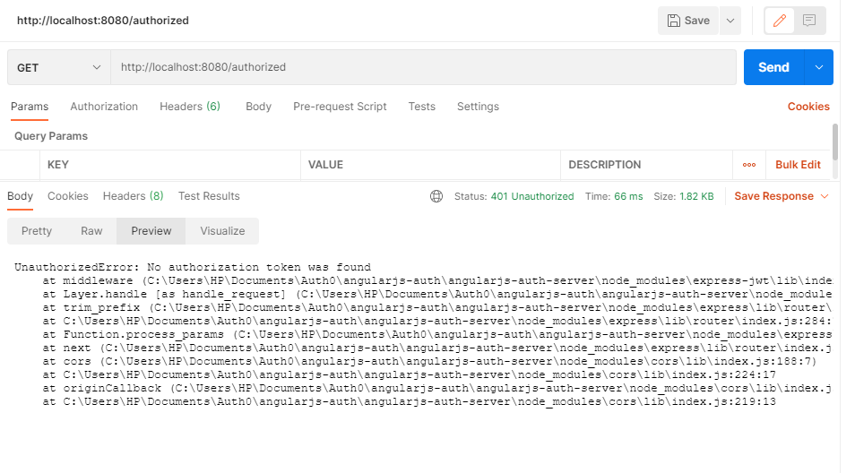

**Add in app.js**

 angularAuth0Provider.init({

      clientID:'X4Z5WYbib240wMajzrQ3Y9YmFyUKcBzG',

      domain:'anushka-cd.us.auth0.com',

      responseType:'token id_token',

      redirectUri:'http://localhost:3000/callback',

      scope:'openid profile',

      audience: 'http://anushka-cd.us.com/api'

   });

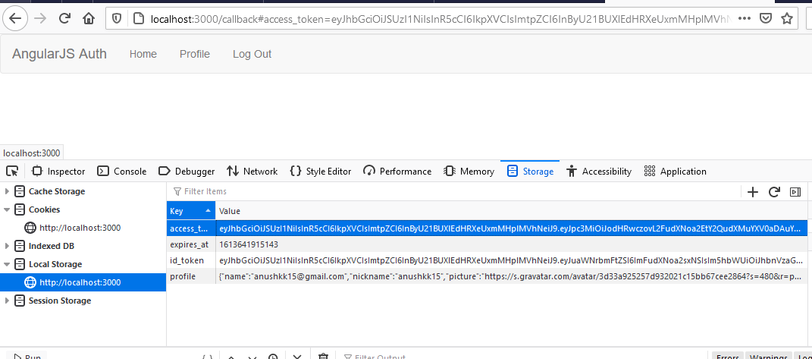

**In postman:**

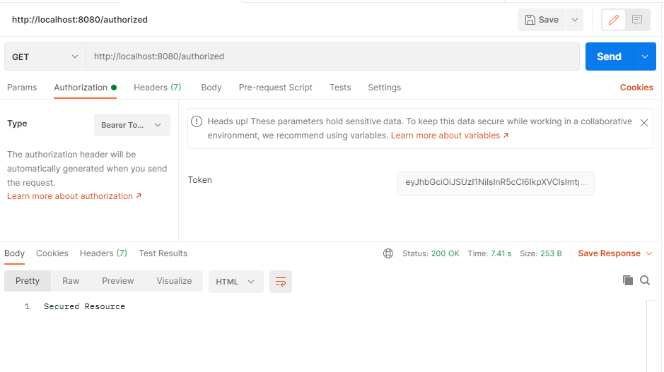

**Setting up HTTP request from angular so that they include access token in them**

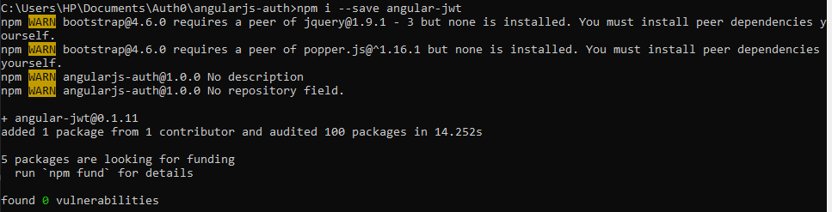

var vm=this;

    vm.message='';

    vm.getMessage=function(){

        $http.get('http://localhost:8080/authorized').then(

            function(result){

               vm.message =result.data;

            },function(err){

                console.log(err);

            }

        );

    };

**Index.html**

 <script src="node_modules/angular-jwt/dist/angular-jwt.js"></script>

**App.js**

(function(){

angular

.module('app',['auth0.auth0','ui.router','angular-jwt'])

.config(config);

config.$inject=[

    '$stateProvider',

    '$locationProvider',

    '$urlRouterProvider',

    '$httpProvider',

    'angularAuth0Provider',

    'jwtOptionsProvider'

];

function config($stateProvider,$locationProvider,$urlRouterProvider,$httpProvider,angularAuth0Provider,jwtOptionsProvider)

{

   $stateProvider

   .state('home',{

    url:'/',

    controller:'HomeController',

    templateUrl:'app/home/home.html',

    controllerAs:'vm'

   })

   .state('callback',{

      url:'/callback',

      controller:'CallbackController',

      templateUrl:'app/callback/callback.html',

      controllerAs :'vm'

   })

   .state('profile',{

      url:'/profile',

      controller:'ProfileController',

      templateUrl:'app/profile/profile.html',

      controllerAs :'vm'

   }) ;

   angularAuth0Provider.init({

      clientID:'X4Z5WYbib240wMajzrQ3Y9YmFyUKcBzG',

      domain:'anushka-cd.us.auth0.com',

      responseType:'token id_token',

      redirectUri:'http://localhost:3000/callback',

      scope:'openid profile',

    audience: 'http://anushka-cd.us.com/api'

   });

   jwtOptionsProvider.config({

      tokenGetter:function(){

         return localStorage.getItem('access_token');

      },

      whiteListedDomains:['localhost']

   })

$httpProvider.interceptors.push('jwtInterceptor');

$urlRouterProvider.otherwise('/');

$locationProvider.hashPrefix('');

$locationProvider.html5Mode(true);

}

})();

**Server.js : (api)**

app.get('/authorized', function (req, res) {

    //res.send('Secured Resource');

    res.json({message:'This is a secure endpoint'});

});

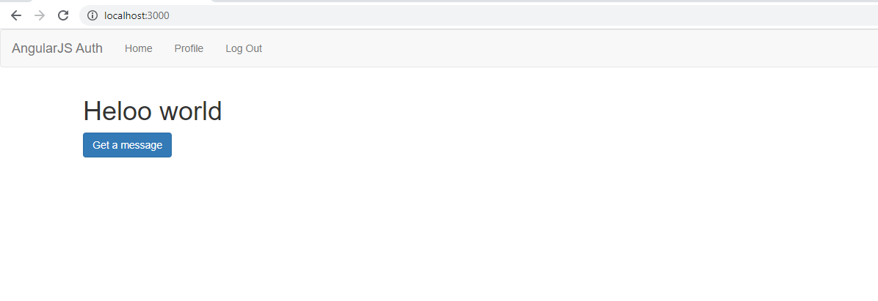

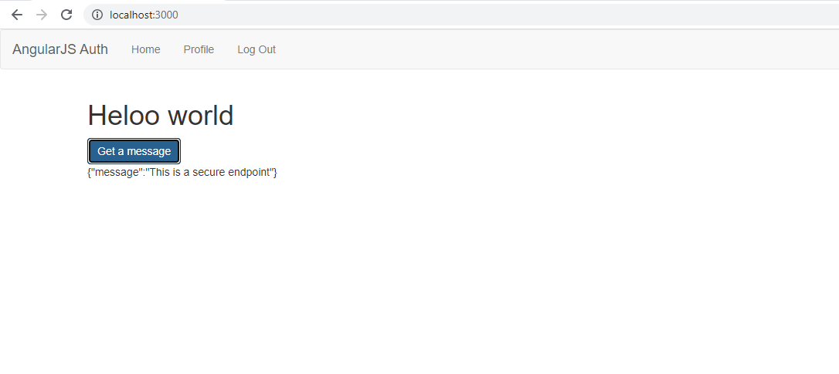

**The test what????(without the button thingy)**

**First the login and then**

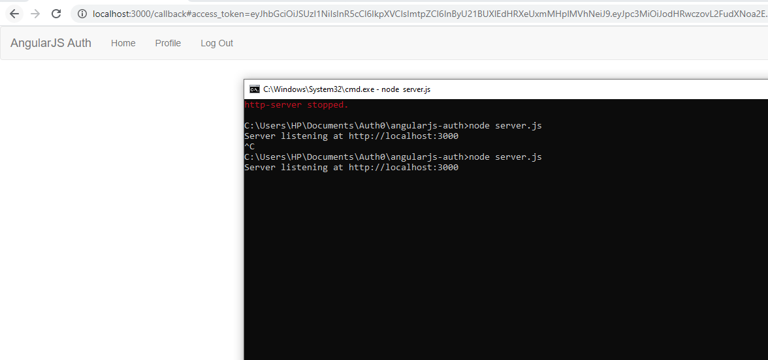

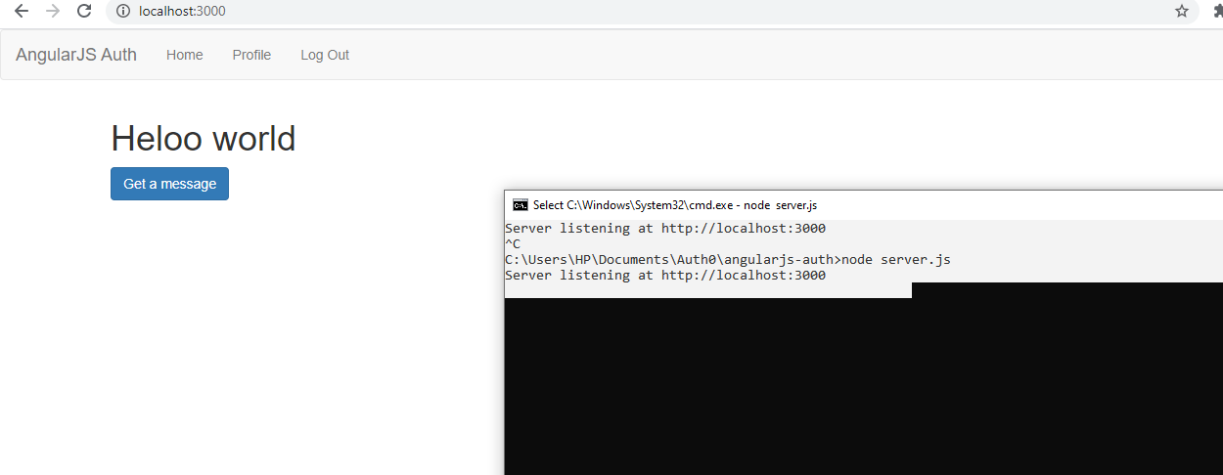

**Test 2:**

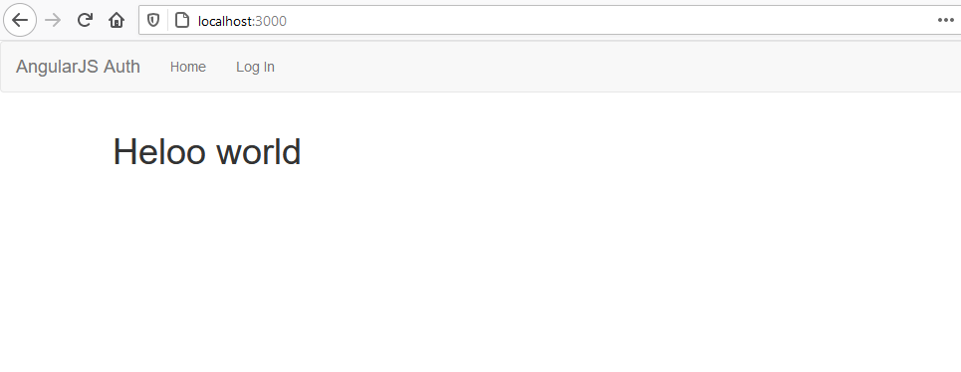

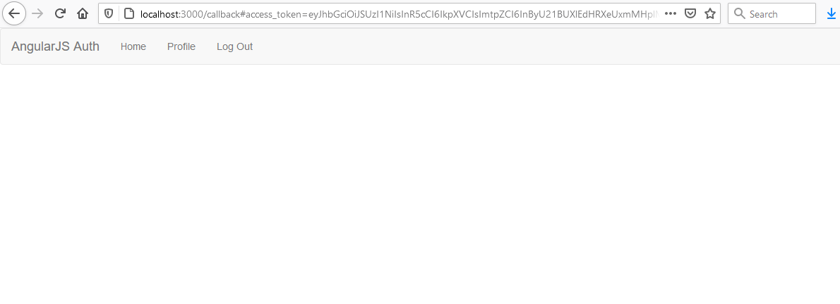

**Open again with node server.js 3000 then**



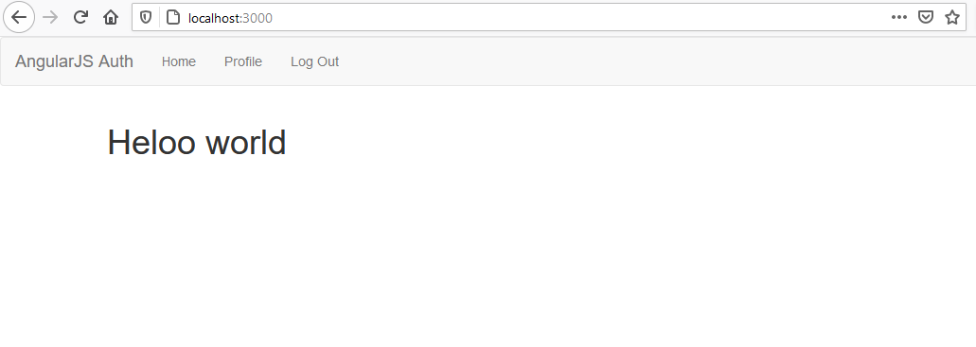

**With button thingy but no 8080:**

**Home.html**

h1>Heloo world</h1>

<button  ng-click="vm.getMessage()"class="btn btn-primary">

    Get a message

</button>

<p ng-if="vm.message">{{vm.message}}</p>

[**Home.controller.js**](http://Home.controller.js)

(function(){

angular.module('app').controller('HomeController',homeController)

homeController.$inject=['$http'];

function homeController($http){

    var vm=this;

    vm.message='';

    vm.getMessage=function(){

        $http.get('http://localhost:8080/authorized').then(

            function(result){

               vm.message =result.data;

            },function(err){

                console.log(err);

            }

        );

    };

}

})();

**Navbar.html**

   <a ui-serf="home">Home</a>

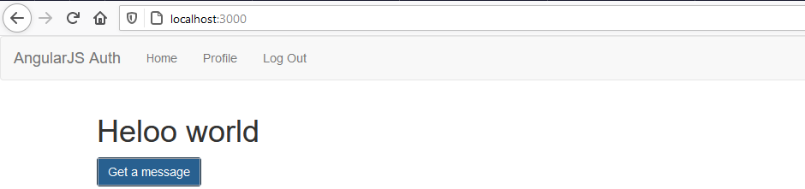

**Now on 8080**

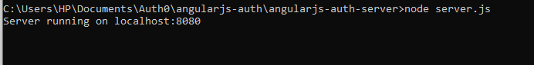

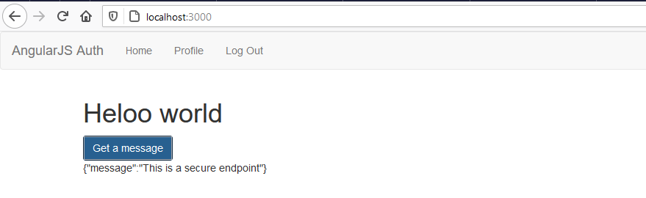

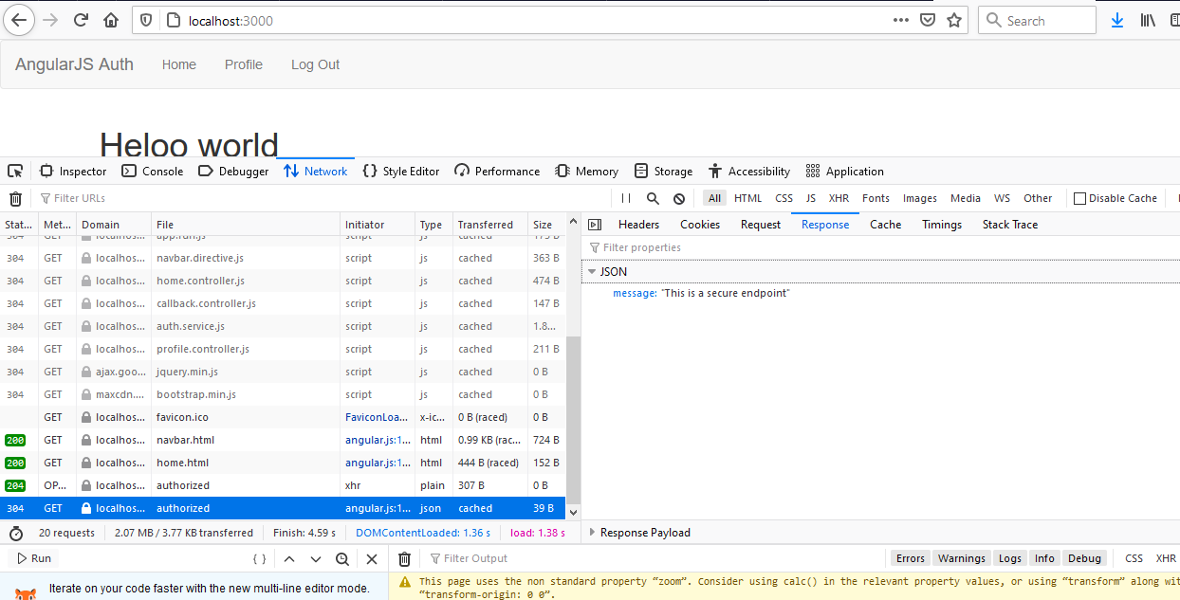

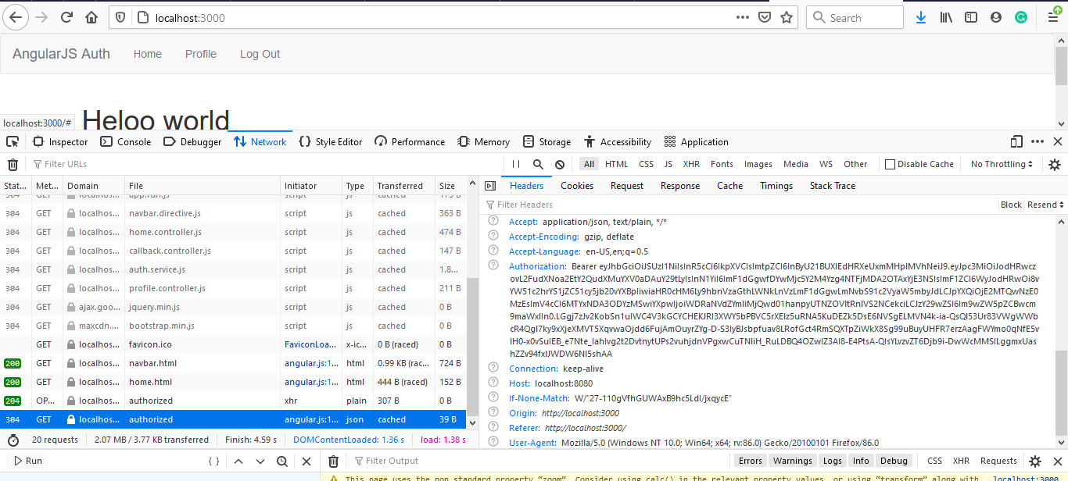

**To remove that callback url when u login:**

**Auth.service.js**

 function handleAuthentication(){

            angularAuth0.parseHash(function(err,authResult){

               if(authResult && authResult.accessToken && authResult.idToken)

               {

               setSession(authResult)

                //console.log(authResult);

                $timeout(function(){

                    $state.go('home');

                });

               }

             });

        }

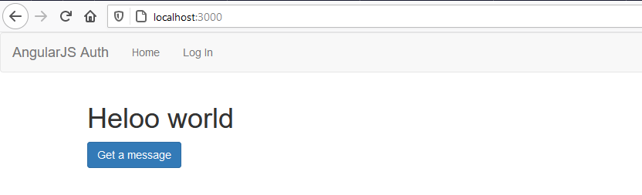

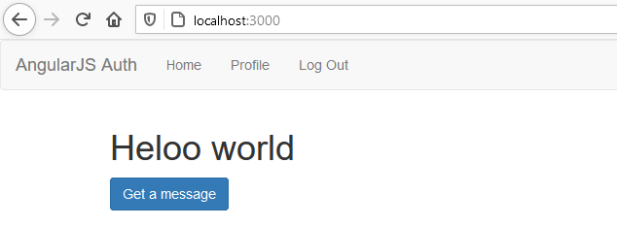

**For button and profile alteration:**

**Home.html**

<h1>Heloo world</h1>

<div ng-if="vm.auth.isAuthenticated()">

<button  ng-click="vm.getMessage()"class="btn btn-primary">

    Get a message

</button>

<p ng-if="vm.message">{{vm.message}}</p>

</div>

[**Home.controller.js**](http://Home.controller.js)

(function(){

angular.module('app').controller('HomeController',homeController)

homeController.$inject=['$http','authService'];

function homeController($http,authService){

    var vm=this;

    vm.auth=authService;

    vm.message='';

    vm.getMessage=function(){

        $http.get('http://localhost:8080/authorized').then(

            function(result){

               vm.message =result.data;

            },function(err){

                console.log(err);

            }

        );

    };

}

})();

**Profile.controller.js**

(function(){

    angular.module('app').controller('ProfileController',profileController)

    profileController.$inject=['authService']

function profileController(authService){

    var vm=this;

    vm.auth=authService;

    vm.profile=JSON.parse(localStorage.getItem('profile'));

}

})();

**Profile.html**

<div ng-if="vm.auth.isAuthenticated()" class="panel panel-default">

<div class="panel-heading">

    <h3>

        Profile

    </h3>

</div>

<div class="panel-body">

    <img ng-src="{{vm.profile.picture}}" alt="avatar">

<div>

<label for="nickname">Nickname</label>

<h3>{{vm.profile.nickname}}</h3>

<label for="name">Name</label>

<h3>{{vm.profile.name}}</h3>

</div>

</div>

</div>

MULTI-FACTOR AUTHENTICATION

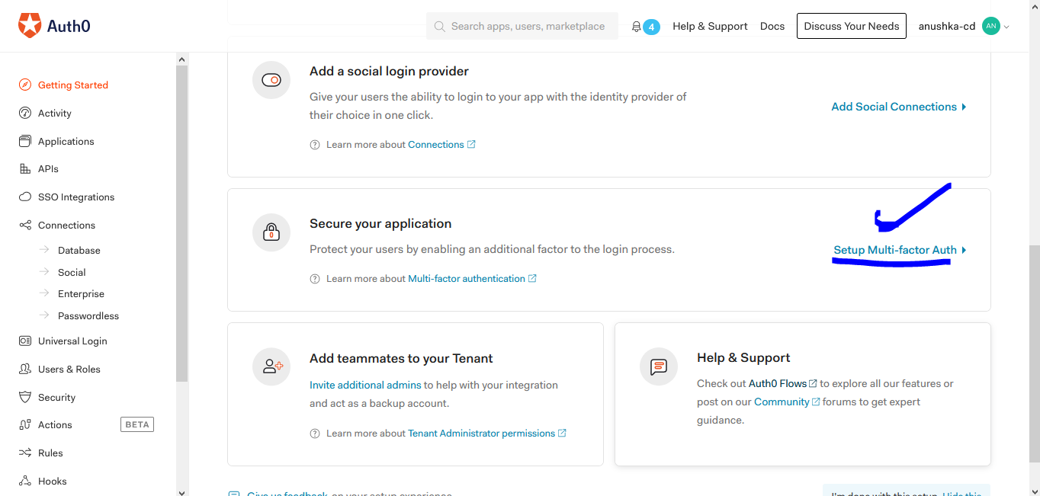

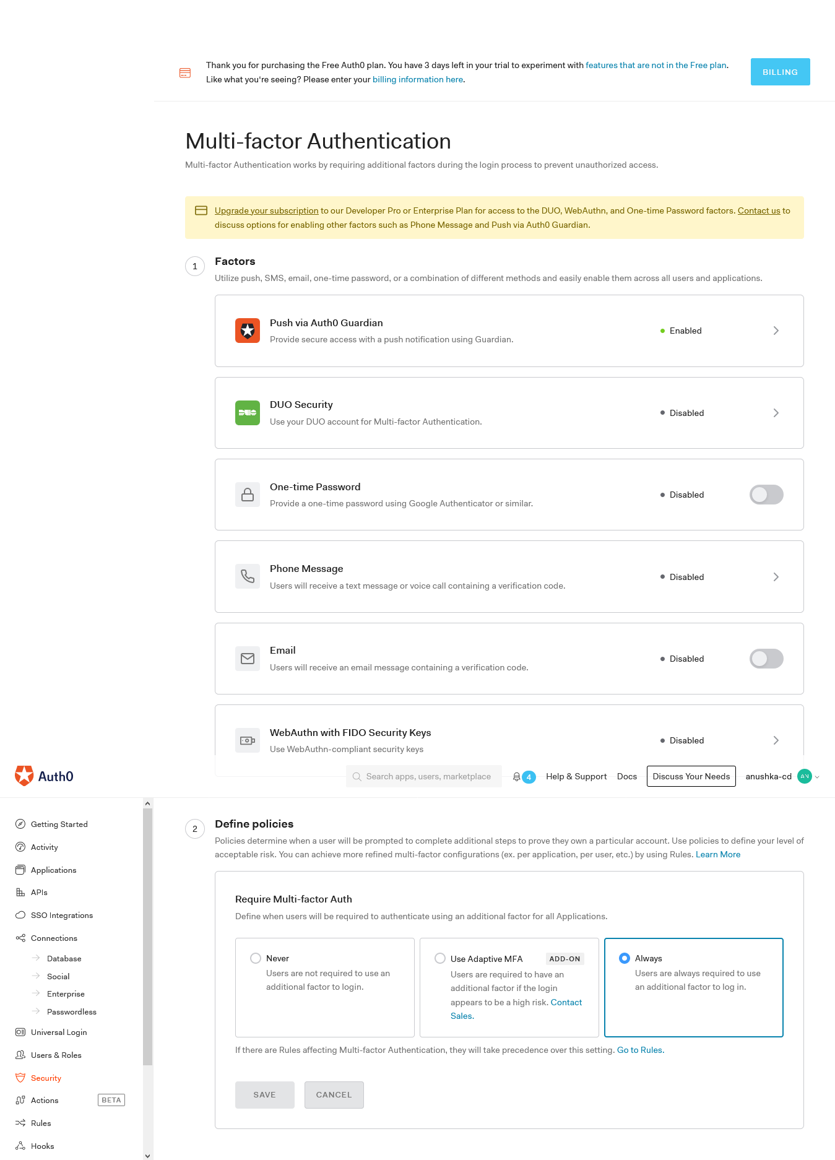

SO when you login this happens



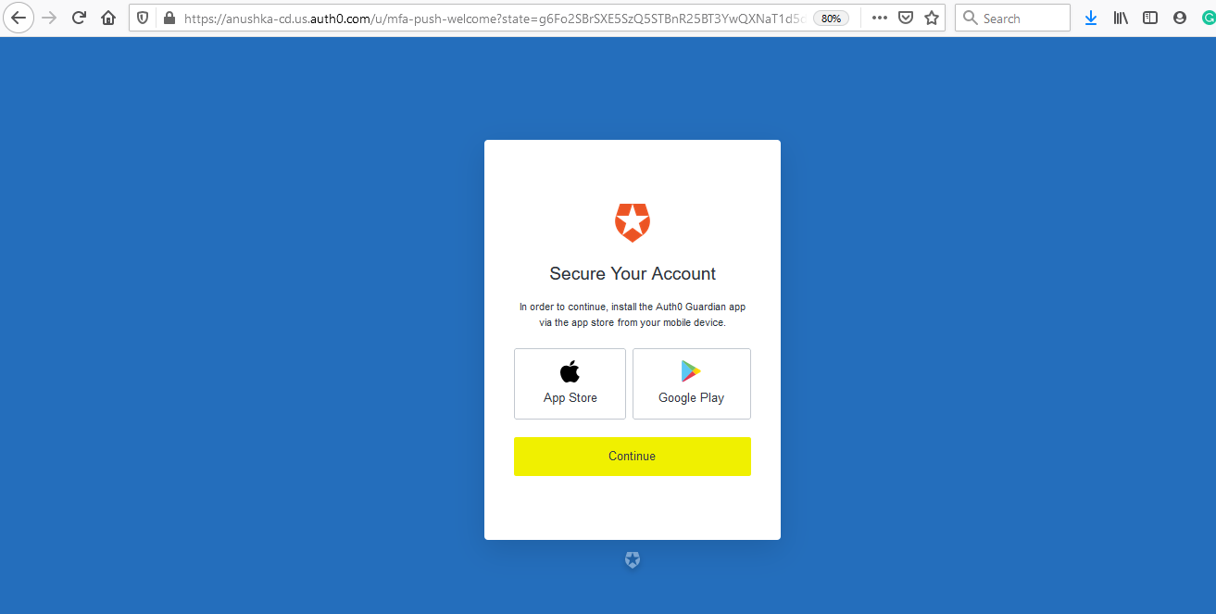

9LD3WZ68QFDS9589V4RM1LAP

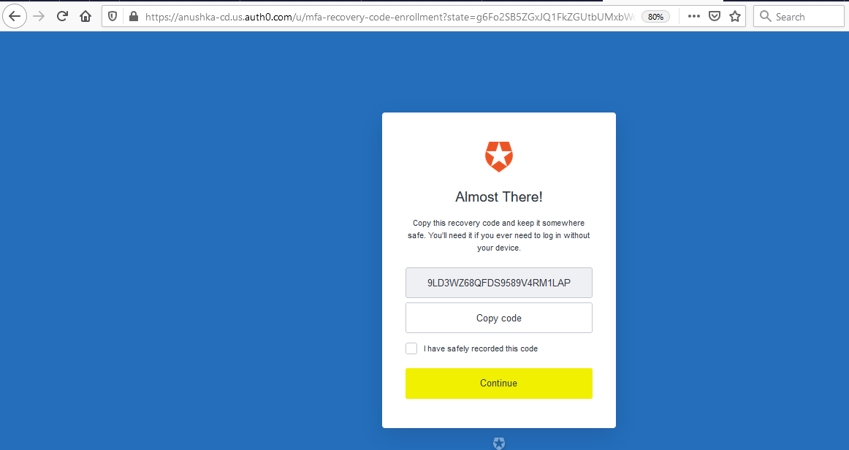

NEXT LOGIN:

